

# Rossmoyne Senior High School

### Semester One Examination, 2016

### Question/Answer Booklet

# MATHEMATICS

If required by your examination administrator, please place your student identification label in this box

**APPLICATIONS**

**UNIT 1**

## Section One:

## Calculator-free

|  |  |  |  |  |  |  |  |  |
| --- | --- | --- | --- | --- | --- | --- | --- | --- |
| Student Number: In figures |  |  |  |  |  |  |  |  |

In words

Your name

## Time allowed for this section

Reading time before commencing work: five minutes

Working time for section: fifty minutes

## Materials required/recommended for this section

***To be provided by the supervisor***

This Question/Answer Booklet

Formula Sheet

***To be provided by the candidate***

Standard items: pens (blue/black preferred), pencils (including coloured), sharpener, correction fluid/tape, eraser, ruler, highlighters

Special items: nil

## Important note to candidates

No other items may be taken into the examination room. It is **your** responsibility to ensure that you do not have any unauthorised notes or other items of a non-personal nature in the examination room. If you have any unauthorised material with you, hand it to the supervisor **before** reading any further.

## Structure of this paper

|  |  |  |  |  |  |
| --- | --- | --- | --- | --- | --- |
| Section | Number of questions available | Number of questions to be answered | Working  time (minutes) | Marks available | Percentage of exam |
| Section One:  Calculator-free | 7 | 7 | 50 | 52 | 35 |
| Section Two:  Calculator-assumed | 12 | 12 | 100 | 98 | 65 |
|  | | | **Total** | 150 | 100 |

## Instructions to candidates

1. The rules for the conduct of examinations are detailed in the school handbook. Sitting this examination implies that you agree to abide by these rules.
2. Write your answers in this Question/Answer Booklet.
3. You must be careful to confine your response to the specific question asked and to follow any instructions that are specified to a particular question.
4. Spare pages are included at the end of this booklet. They can be used for planning your responses and/or as additional space if required to continue an answer.

* Planning: If you use the spare pages for planning, indicate this clearly at the top of the page.
* Continuing an answer: If you need to use the space to continue an answer, indicate in the original answer space where the answer is continued, i.e. give the page number. Fill in the number of the question that you are continuing to answer at the top of the page.

1. **Show all your working clearly**. Your working should be in sufficient detail to allow your answers to be checked readily and for marks to be awarded for reasoning. Incorrect answers given without supporting reasoning cannot be allocated any marks. For any question or part question worth more than two marks, valid working or justification is required to receive full marks. If you repeat any question, ensure that you cancel the answer you do not wish to have marked.
2. It is recommended that you **do not use pencil**, except in diagrams.
3. The Formula Sheet is **not** to be handed in with your Question/Answer Booklet.

Section One: Calculator-free 35% (52 Marks)

This section has**seven (****7)** questions. Answer **all** questions. Write your answers in the spaces provided.

Working time for this section is 50 minutes.

Question 1 (5 marks)

(a) Evaluate

(i) . (1 mark)

(ii)  when . (1 mark)

(b) Given , determine

(i) A when  and . (1 mark)

(ii) h when  and . (2 marks)

Question 2 (8 marks)

A casual worker submitted the weekly time sheet below. On Saturdays and Sundays, casuals are paid time and a half and double time respectively.

|  |  |  |  |  |  |  |  |
| --- | --- | --- | --- | --- | --- | --- | --- |
| Time sheet | Normal hourly pay rate | | | $20 |  |  |  |
|  | Mon | Tue | Wed | Thu | Fri | Sat | Sun |
| Hours worked | - | - | - | 3.5 | 5.5 | 4 | 5 |

(a) How many hours did the casual worker work during this week? (1 mark)

(b) How much did the casual worker earn

(i) on Friday? (1 mark)

(ii) on Saturday? (1 mark)

(iii) for this week's work? (2 marks)

(c) The previous week, the casual worker had $30 deducted for PAYG tax from their total earnings of $400. What percentage of their week's earnings was this? (2 marks)

(d) If casual workers were awarded a 4% pay increase, what would the new normal hourly rate become? (1 mark)

Question 3 (5 marks)

The number of different bus services that run between four locations is shown in the table below and also in the matrix M.

|  |  |  |  |  |  |
| --- | --- | --- | --- | --- | --- |
|  |  | To | | | |
|  |  | A | B | C | D |
| From | A | 0 | 1 | 1 | 0 |
| B | 2 | 0 | 2 | 0 |
| C | 1 | 1 | 0 | 1 |
| D | 0 | 0 | 1 | 0 |



(a) Briefly explain the information shown in the matrix  (1 mark)

(b) Complete the diagram below to show the information in the table. (2 marks)

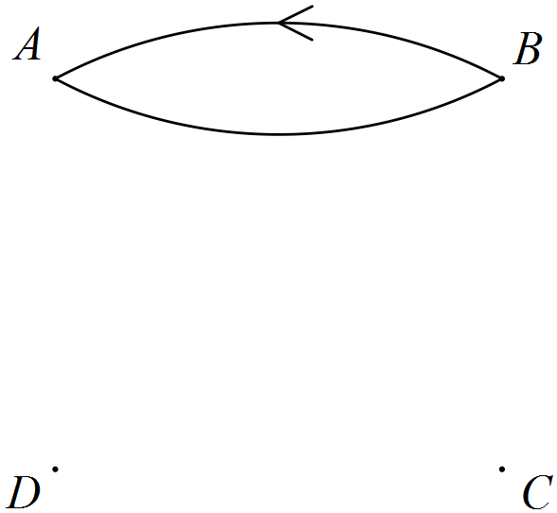

(c) State the number of ways to travel from D to B using two bus services. (1 mark)

(d) How many more ways are there to travel from B to C than from C to B, using either one or two bus services? (1 mark)

Question 4 (10 marks)

Consider matrices , ,  ,  and .

(a) Explain which two, if any, of the five matrices can be added together. (2 marks)

(b) Calculate . (2 marks)

(c) Determine the values of x and y if . (2 marks)

(d) Calculate , where I is the identity matrix. (2 marks)

(e) Determine an order in which all five matrices can be multiplied together and state the dimensions of the resulting matrix. (2 marks)

Question 5 (7 marks)

The distance, d metres, travelled by a body accelerating at a metres per second, in t seconds is given by the formula .

(a) Calculate d when

(i)  and . (1 mark)

(ii)  and . (1 mark)

(b) Calculate the distance travelled by the body between  and  when .

(3 marks)

(c) Determine a when  and . (2 marks)

Question 6 (8 marks)

A solid piece of plastic in the shape of a rectangular prism had the corner cut off, as shown in the diagram below.

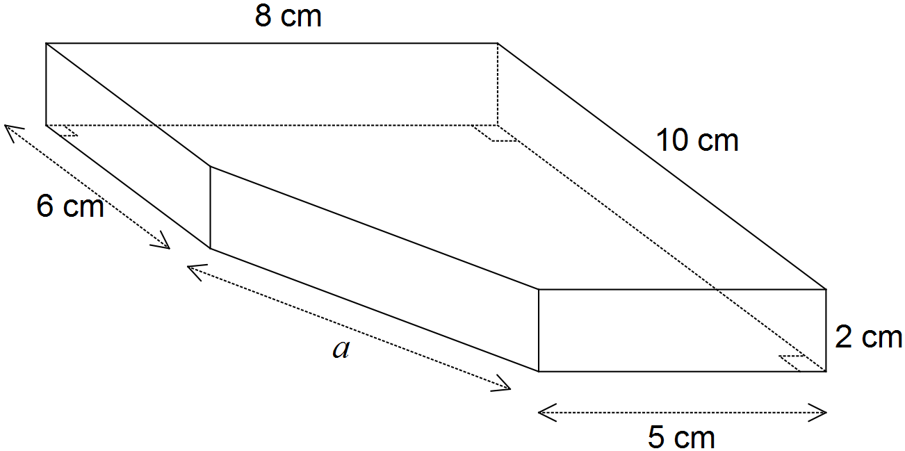

(a) Calculate the volume of the solid shown above. (3 marks)

(b) Determine the length of the edge marked a in the diagram. (2 marks)

(c) Calculate the total surface area of the solid. (3 marks)

Question 7 (9 marks)

Fred, Gail and Harry worked in a motor vehicle dealership. During May they sold 11, 14 and 12 cars and 5, 1 and 2 vans respectively. In the following month, the three sold a total of 30 cars and 10 vans, of which Fred sold 13 cars and 4 vans and Gail sold 9 cars and 3 vans.

(a) Organise the above information into two matrices to show the number of cars and vans sold by Fred, Gail and Harry during May and June. (3 marks)

(b) Write a matrix calculation to determine the change in the number of cars and vans sold by Fred, Gail and Harry from May to June, and write the answer to this calculation. (2 marks)

(c) Fred, Gail and Harry are paid $5 000, $ 4 800 and $ 4 500 per month respectively. They are also paid bonuses of $200 for each car they sell and $300 for each van in any given month.

(i) Write down a calculation involving three matrices, that would result in a matrix showing the monthly pay owed to Fred, Gail and Harry for the month of May.

(2 marks)

(ii) Evaluate your answer to (i). (2 mark)

Additional working space

Question number: _________

© 2016 WA Exam Papers. Rossmoyne Senior High School has a non-exclusive licence to copy and communicate this paper for non-commercial, educational use within the school. No other copying, communication or use is permitted without the express written permission of WA Exam Papers.